Project Management Tool

(Starks Project Management Tool - SPM)

# Requirements Specification

Author(s):

Linton Starks

# Revision History

|  |  |  |  |
| --- | --- | --- | --- |
| *Date* | *Version* | *Description* | *Author* |
| 21/03/2021 | 1.0 | Initial Draft | Linton Starks |
|  |  |  |  |
|  |  |  |  |

Table of Contents

Requirements Specification 1

Revision History 2

# Introduction

Project management involves planning, organizing, and managing resources in order to successfully meet project goals and objectives. This is accomplished through the use of processes, which are discrete units of work that are required for the completion of a project. A process is defined in terms of its inputs, its tools and techniques, and its outputs. Inputs and outputs include, but are not limited to, documents, plans, and designs. Tools and techniques are the mechanisms applied to the inputs that result in the outputs of a process. There are several possible processes over different Process Groups and each individual project is composed of a subset of these processes. Dependencies exist among many of the processes in that the output of one process is often required as the input of another.

Our task is to develop a web-based application that will allow for the management of a project through the maintenance of a database that will contain each of the processes required for the project as well as the inputs and outputs of each of the processes. Furthermore, the application will provide the users with a visual representation of the processes used in the project as well as the dependencies among those processes.

# The Purpose of the Product

## Goals of the Project

The Project Management Tool project has the following goals:

* + 1. Provide users with an interface through which they may log into the system
    2. Provide project managers with an interface through which they may initialize a new project.
    3. Provide project managers with an interface through which they may dynamically add or remove processes from a particular project.
    4. Provide project managers with a system alerting them of inconsistencies in process dependencies among the processes chosen for a project.
    5. Provide project managers as well as team members with an interface through which they may view all of the processes for a project in the form of a dependency graph.
    6. Provide project managers as well as team members with an interface through which they may update the inputs, outputs, and status of a process including risk notifications and constraints on budget.
    7. Provide routine project status reports to project manager
    8. Obtain information from and make changes to the database quickly and accurately.
    9. Provide an intuitive and convenient GUI to maximize ease of use.

## Scope of the Project

The scope of the project will cover the following:

* + 1. Elicit the product requirements from the client and refine the requirements into a detailed specification document.
    2. Prepare high level as well as detailed design documents describing the system.
    3. Prepare test plan including test cases.
    4. Implement the various modules described in the design documents.
    5. Perform all types of testing (unit, integration, system, regression).
    6. Deliver product to client and follow up on acceptance testing.

# Mandated Constraints

## Solution Design Constraints

The following are the mandated technologies for use: should be determined by development team.

## Implementation Environment of the Current System

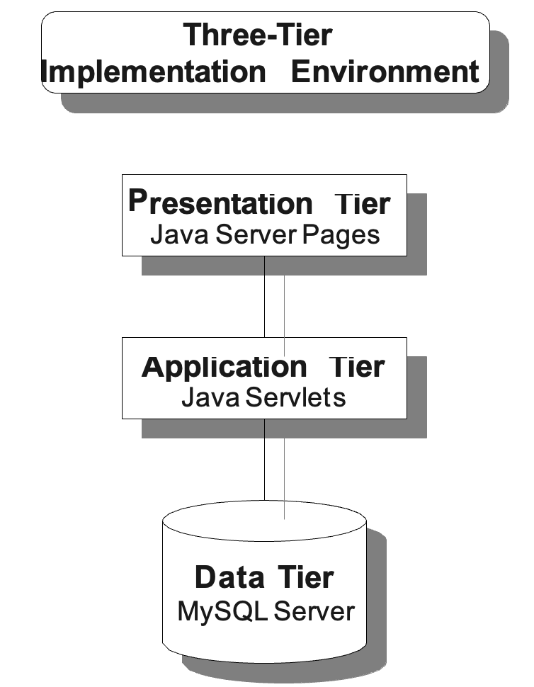

# The Scope of the Work

## Context of the Work

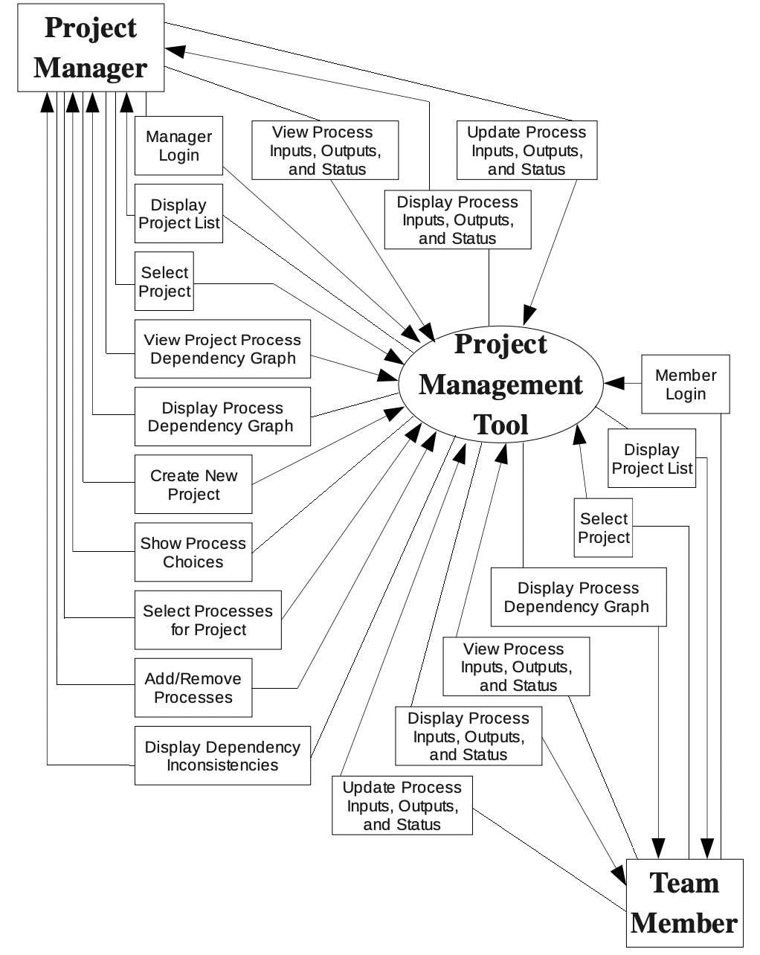

## 4.2 Work Partitioning

|  |  |  |
| --- | --- | --- |
|  | **Event Description** | **Inputs & Outputs** |
| 1 | Manager logs in. | Manager Login (in) Display Project List (out) |
| 2 | Manager selects a project to work on. | Select Project (in)  Display Process Dependency Graph (out) |
| 3 | Manager chooses to select processes to create a new project. | Create New Project (in) Show Process Choices (out) |
| 4 | Manager creates new project by selecting appropriate processes. | Select Processes for Project (in)  Display Dependency Inconsistencies (out) Display Process Dependency Graph (out) |
| 5 | Manager adds or removes processes for a particular project. | Add/Remove Processes (in)  Display Dependency Inconsistencies (out) Display Process Dependency Graph (out) |
| 6 | Manager chooses to view the details of a process (inputs, outputs, status). | View Proc. Inputs, Outputs, & Status (in) Display Proc. Inputs, Outputs, & Status (out) |
| 7 | Manager chooses to update the details of a process | Update Proc. Inputs, Outputs, & Status (in) |
| 8 | Team member logs in. | Member Login (in) Display Project List (out) |
| 9 | Team member selects a project to work on. | Select Project (in)  Display Process Dependency Graph (out) |
| 10 | Team member chooses to view the details of a process. | View Proc. Inputs, Outputs, & Status (in) Display Proc. Inputs, Outputs, & Status (out) |
| 11 | Team member chooses to update the details of a process | Update Proc. Inputs, Outputs, & Status (in) |

Note:

Project budget – should be updated at the end of each milestone

Risk notifications – project manager and team members are notified of potential risk i.e., if tasks are not performed timely against allocated time.

# The Scope of the Product



* 1. **Product Boundary**



1.

Manager login

3.

Select processes for project

2.

Start a new project

5.

Add or remove processes

4.

Open project process dependency graph

7.

Select process to view details

6.

Open project process dependency graph

9.

Team Member login

8.

Update process details

Team Member

Manager

# Functional and Data Requirements

## Functional Requirements

*6.1.1 Requirement: Project Manager Login*

Description: The product shall only allow registered project team managers to log into the system in the project manager role using a unique username and password.

Rationale:

To allow project managers access to only their own accounts and to prevent non-manager users from having access to functions specific to the manager role.

Source: Managers Criterion:

Registered managers shall have access to project management functions including

starting new projects, viewing project process dependency graphs, viewing the details of individual processes, updating the details of individual processes, and adding and removing processes.

Customer Satisfaction: Customer Dissatisfaction: Dependencies: None Conflicts: None Supporting Materials:

History: Created March 21, 2021

* + 1. *Requirement : Start a New Project*

Requirement #: 2

Requirement Type:

Use Case #: 2

Description: The product shall provide to a registered project team manager the option to start a new project.

Rationale:

To allow a manager to use the product for a specific project as well as to allow the product to be scalable to handle multiple projects.

Source: Managers Fit Criterion:

The product shall create unique database table entries for the inputs, outputs, and status

of processes for the new project.

Customer Satisfaction: Customer Dissatisfaction: Dependencies: 1 Conflicts: None Supporting Materials:

History: Created March 21, 2021

* + 1. *Requirement Shell: Select Processes for the Project*

Requirement #: 3

Requirement Type:

Use Case #: 3

Description: The product shall provide to a registered project team manager the option to select the processes required for a new project.

Rationale:

To allow a manager to select only those processes that are applicable or relevant to a particular project.

Source: Managers Fit Criterion:

Registered managers shall have access to all of the 44 processes used in project

management and shall be able to select any subset of the 44 processes. The database shall be updated to contain only the processes selected for the project.

Customer Satisfaction: 5 Customer Dissatisfaction: 5

Dependencies: 1, 2 Conflicts: None Supporting Materials:

History: Created March 21, 2021

* + 1. *Requirement Shell: Open Process Dependency Graph (manager)*

Requirement #: 4

Requirement Type:

Use Case #: 4

Description: The product shall provide to a registered project team manager the option to view the process dependency graph of an existing project.

Rationale:

To allow a manager access to the processes used in the project as well as to allow the manager to visualize the dependencies among those processes.

Source: Managers Fit Criterion:

The product shall render a graphical representation of the processes used in the project as

well as the dependencies that exist among those processes. Customer Satisfaction: 5 Customer Dissatisfaction: 5 Dependencies: 1 Conflicts: None Supporting Materials:

History: Created March 21, 2021

* + 1. *Requirement Shell: Add or Remove Processes*

Requirement #: 5

Requirement Type:

Use Case #: 5

Description: The product shall provide to a registered project team manager the option to dynamically add processes to or remove processes from a project.

Rationale:

To allow a manager to make changes to an existing project in response to changes in client needs, project requirements, budget, or schedule.

Source: Managers Fit Criterion:

Registered managers shall have the ability to select processes from the process

dependency graph to remove from the project. Registered managers shall also have the ability to select any unused processes to add to the project. The database shall be updated to reflect the changes made.

Customer Satisfaction: 5 Customer Dissatisfaction: 5

Dependencies: 1, 4 Conflicts: None Supporting Materials:

History: Created March 21, 2021

* + 1. *Requirement Shell: Dependency Inconsistencies*

Requirement #: 6

Requirement Type:

Use Case #: 3, 5

Description: The product shall notify the user of any inconsistencies in the process dependency graph.

Rationale:

To make the manager aware of inconsistencies so that he or she is able to make decisions to deal with those inconsistencies.

Source: Managers Fit Criterion:

The product shall automatically check for inconsistencies when a project is initialized

and when processes are added to or removed from an existing project. In addition to displaying the project process dependency graph, the product shall also display a list of the processes involved in dependency inconsistencies.

Customer Satisfaction: 5 Customer Dissatisfaction: 5

Dependencies: 1, 4 Conflicts: None Supporting Materials:

History: Created March 21, 2021

* + 1. *Requirement Shell: Team Member Login*

Requirement #: 7

Requirement Type:

Use Case #: 9

Description: The product shall only allow registered project team members to log into the system in the team member role using a unique username and password.

Rationale:

To allow team members access to only the functions specific to the team member role. Source: Team Members

Fit Criterion:

Registered team members shall have access to project management functions including viewing project process dependency graphs, viewing the details of individual processes, and updating the details of individual processes.

Customer Satisfaction: 5 Customer Dissatisfaction: 5 Dependencies: None Conflicts: None Supporting Materials:

History: Created March 21, 2021

* + 1. *Requirement Shell: Open Process Dependency Graph (team member)*

Requirement #: 8

Requirement Type:

Use Case #: 6

Description: The product shall provide to a registered project team member the option to view the process dependency graph of an existing project.

Rationale:

To allow a team member access to the processes used in the project as well as to allow the team member to visualize the dependencies among those processes.

Source: Team Members Fit Criterion:

The product shall render a graphical representation of the processes used in the project as

well as the dependencies that exist among those processes. Customer Satisfaction: 5 Customer Dissatisfaction: 5 Dependencies: 7 Conflicts: None Supporting Materials:

History: Created March 21, 2021

*6.1.9* *Requirement Shell: View Process Details*

Requirement #: 9

Requirement Type:

Use Case #: 7

Description: The product shall allow project team managers and team members to view the details of any process in the process dependency graph.

Rationale:

To allow managers and team members access to information regarding the state of a particular process.

Source: Managers, Team Members Fit Criterion:

Users shall be able to view the inputs, outputs, and status of any process in the process

dependency graph.

Customer Satisfaction: 5 Customer Dissatisfaction: 5

Dependencies: 4, 8 Conflicts: None Supporting Materials:

History: Created March 21, 2021

* + 1. *Requirement Shell: Update Process Details*

Requirement #: 10

Requirement Type:

Use Case #: 8

Description: The product shall allow project team managers and team members to make changes to the details of any process in the process dependency graph.

Rationale:

To allow managers and team members the ability to update the details of a process to reflect its current state.

Source: Managers Fit Criterion:

Users shall be able to change the inputs, outputs, and status of any process in the process

dependency graph. The database shall be updated to reflect the changes to the processes. Customer Satisfaction: 5 Customer Dissatisfaction: 5

Dependencies: 9 Conflicts: None Supporting Materials:

History: Created March 21, 2021